**Introduction**

This study is designed to find the factors that go into what makes influencers so influential towards followers and why people choose to follow them. We want to investigate these factors and how they can contribute to a long-term relationship between an influencer and a follower. It is also important to see how a brand-influencer relationship affects the feelings followers have toward influencers. We want to see how the type of product/service influencers promote can affect the followers' opinions toward them. There are two scenarios given: the influencer promotes a product that fits into the category of content the influencer usually posts (lifestyle, health, video games, etc.), and the influencer promotes a product outside of their typical category of content. The factors that we use to determine what types of opinions followers form based on these scenarios include loyalty, trust, authenticity, expertise, physical attractiveness, homophily, attitude toward the influencer, product attitude, and purchase intention.

Understanding how these factors affect the opinions followers have towards influencers is important because it can help us understand how influencers attract long-term followings, thus showing their ability to be successful in a digital landscape. Influencer marketing has also become a large part of brands’ marketing strategy. Brands can use influencers to promote products through a raw and authentic platform, so understanding the opinions of followers can help brands choose the correct influencers to promote their products.

Previous research on this topic has uncovered that the factors of expertise, authenticity and homophily play a role in developing trust between an influencer and a follower. Similar findings have shown that homophily and followers’ feelings that are similar to influencers can establish a relationship of trust. Research has also shown that the link between trust and physical attraction is not significant towards the relationship of influencers and followers. Although, there is significance between homophily and purchase intent. Furthermore, research shows that the effects of trust and loyalty are significant when relationships among influencers and followers are strong.

**Research Method**

This study pulls from past research done about influencers and followers’ relationships but becomes more comprehensive by considering several more factors. The survey is distributed through Qualtrics to college students. This study specifically focuses on college students' views toward influencers, considering the demographics of participants, specifically that the responses are coming from a group of individuals where social media and influencers are a large part of this community. This study also uses two scenarios to manipulate how the type of product being promoted correlates with the type of content influencers post and how followers react to that. Their reactions would determine how the factors of an influencer-follower relationship change depending on if the products promoted fit with the type of content influencers post.

**Overview of Experiment**

Considering this information, we can identify a few hypotheses for the study. There are several constructs we used to assess the effects of purchase intention based on the given condition. These included: expertise, purchase intent, loyalty, trust, authenticity, physical attraction, homophily, attitude, and product attitude. The primary goal was to look at the relationship between purchase intent and condition, with all other constructs possibly being mediators.

**Hypothesis 1:** Purchase intent and condition will be positively significantly correlated dependent on the condition: for in-domain endorsements, purchase intent will increase. For out-of domain endorsements, purchase intent will decrease.

**Hypothesis 2:** Purchase intent will be significantly correlated with product attitude**.**

**Hypothesis 3a:** Endorsements related to the influencer's domain/normal content will be positively correlated to loyalty, authenticity, trust, homophily and expertise.

**Hypothesis 3b:** There will be a negative relationship between authenticity, loyalty, trust, homophily, expertise and the endorsements of products unrelated to the influencers standard domain.

**Hypothesis 4:** The physical attraction does not have any effect on the manipulation.

Method

We created two conditions where one condition was randomly given to each participant to get close to equal responses for each condition. To make the study as accurate as possible, each respondent had to indicate their favorite influencer whom the following questions would then be answered on. Participants answered questions about all constructs for the condition they received. Although the conditions were opposite of one another, all other questions were identical to eliminate bias and receive the most accurate results. The survey had 216 responses. We then cleaned the data to exempt inaccurate or missing values.

Results

Figure 1

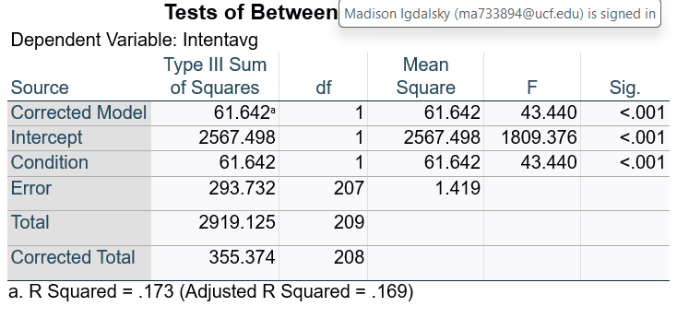

Figure 2

Figure 3

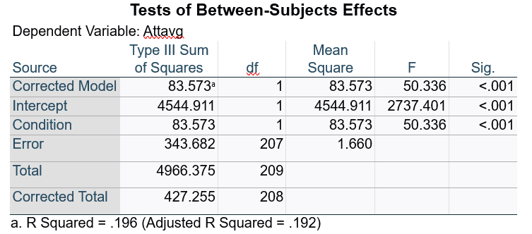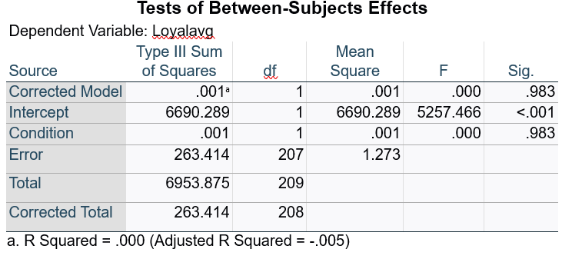

Figure 4

Figure 5

Figure 6

Based on our prediction, using ANOVA, we found that a condition type would significantly impact purchase intent. (Figure 1). This is consistent with H1. We also found that attitudes toward influencers are so strong and loyal that consumers are willing to forgive the influencer for endorsing a product unrelated to the influencer’s domain, confirming and further finding answers to H2 (Figure 2). But expertise matters. Although H3 considered many constructs, we found that the expertise of an influencer on a certain product is significant with a consistent purchase intention and not any of the other factors (loyalty, authenticity, trust, and homophily) (Figure 3-6). Expertise on purchase intention showed p<.001.

Figure 7

Figure 8

We wanted to further investigate the significance of this mediating factor so we ran a bootstrapping analysis. Based on Hayes bootstrapping model, model 4, the condition of the influencer using a product inconsistent with their typical posts' affects the expertise of the influencer. Expertise had a significant negative effect on purchase intent. Since Model 4 demonstrated bootstrapping to be other than 0, it shows that expertise is a significant mediating factor of condition and purchase intention. Lastly the relationship between the condition and purchase intent without the mediating factor of expertise was not significant. (Graph 7)**.** To further investigate if there were more significant mediating factors, using bootstrapping on Hayes Model 6, we found significance in that endorsing an inconsistent product negatively changes consumers perception on the purchase attitude (p<.001) (Graph 8). Since this influences purchase attitude, it leads to significance in lower purchase intent (p<.001). With this model we also found no correlation between normal endorsements and higher purchase attitude directly (p=.21). This model also shows no direct connection between a normal endorsement and purchase intent. The findings show that having low expertise plays a significant role in negatively impacting consumer attitude and ultimately ending in lower purchase intent. Without expertise followed by purchase attitude, there is not much impact on endorsing an inconsistent product and decreased purchase intention.

Figure 9

Circling back to H4, our hypothesis proved to be correct in that physical attraction has nothing to do with purchase intent given either condition. (Graph 9).

Discussion

These findings show that out-of-domain endorsements lead to lower attitudes toward the influencer and lower purchase intentions. Although, there was no effect on loyalty at all. This is interesting because it shows consumers like these influencers so much that they are aware of the decrease in expertise, but it does not affect their devotion to their favorite influencer. The findings show that expertise plays a significant role in purchase intention based on the influencer’s endorsement of a product. Both Hayes models 4 and 6 further signify that consumers cannot go without the factor of expertise when considering buying a product from their influencer, but factors such as authenticity, trust, and loyalty are not large factors.